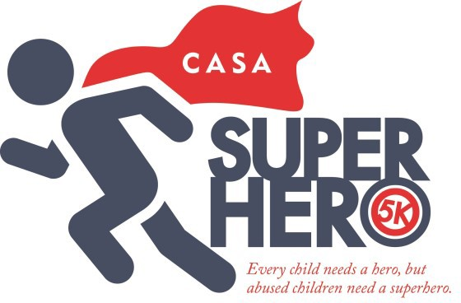
APRIL 30, 2022
White Oaks – Bridgeport, WV

Registration Form

Please check this box if entry is included with a sponsorship. Included with the following sponsor: _

Name: Date of Birth: Age on race day: Address: City: State: Zip Code: Gender: M or F Email: Phone:
Which race are you registering for? (Check one)
Timed 5K Runner 5K Timed Walker* Kids’ Villain Chase
(*Kids’ Villain Chase participants will not be timed and will not be included in the timing awards)

5K Registrants Only—Shirt Type & Size: (Villain Chase participants receive superhero cape only with registration)
Standard Tee: Adult: S M L XL XXL XXXL Youth: S M L XL

Tec Tee: (Additional $5 Fee) Men: S M L XL

Registration Fees: (Please mark your selection)

Women: S M L XL

$10—Kids’ Villain Chase (includes Superhero Cape—guaranteed if registered by 3/31/22)
$25—5K (before 3/31/22 with standard T-shirt)
$30—5K (before 3/31/22 with Tec Tee)
$25—5K (after 3/31/22; no guarantee of shirt) *Same day registration is also available*
Make checks payable to: CASA (Please write Superhero 5K in memo)
Mail entry to: CASA, P.O. Box 1876, Clarksburg, WV 26302

CASA Superhero 5K Race Waiver: I hereby—for myself, my executors, and my administrators—waive any and all rights I may have against CASA of Marion County and Harrison County CASA Program, Inc. or any other agency associated with this event, sponsors of this event, or suppliers for injury or damages suffered by me or my child(ren), and which may arise out of or any way be connected with this event. I understand that my participation is voluntary and I recognize that there are risks and hazards inherent in my participation to myself and to others, and I knowingly assume all responsibility and risk involved in this event. I further agree that all photographs taken by the CASA Superhero 5K representatives during the event, or likenesses rendered from these photographs, become the property of the CASA Superhero 5K and may be used to promote the CASA Superhero 5K event or other activities.

I agree to the Race Waiver Above:

@CASASuperhero5KWV @CASA5KSuperhero @casasuperhero5kwv

